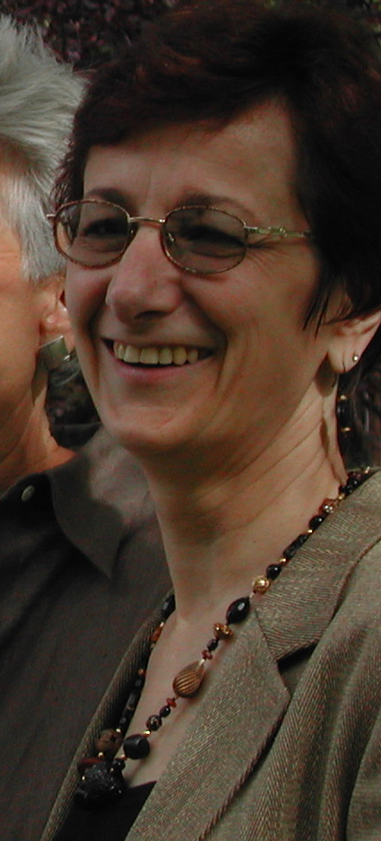
Diane Gilman

Diane Gilman is the Director of the Maine Chapter and New England Region of the National Coalition Building Institute International (NCBI). Her role as director focuses on developing teams of leaders and creating welcoming environments for all people in schools, universities, communities and businesses. NCBI's mission is to create ethical leaders who model Prejudice Reduction, Coalition Building and Conflict Resolution skills in every aspect of their lives. Diane inspires leadership in everyone she works with. Before joining NCBI, Diane managed her own consulting firm specializing in Managing Diversity and Leadership Development. Diane brings 16 years experience in human resources, training and education, materials, and manufacturing in both management and consultant positions. She is noted for her work in Valuing and Managing Diversity, Management and Workforce Development, Employee Relations, Human Resource Planning, and Organization Development. Diane has great enthusiasm and commitment for the work of building bridges across diverse group lines.

Diane has particular expertise in working with white people on the elimination of racism. Through her leadership, the Maine Chapter of NCBI completed a 6 month pilot project with leaders throughout the State of Maine called, “White People Confronting Racism: Vision to Action”. This work is ongoing. She has also created an intervention for school systems throughout the State called “Breaking the Cycle of Violence: Stopping Teasing and Harassment in Schools”.

NCBI/Maine Mission Statement: To develop teams of leaders who take principled and courageous stands to create safe, welcoming, and equitable environments for all people through programs in prejudice reduction and conflict mediation, and by developing collaborative partnerships.

Diane received her Bachelor of Arts in Speech from Emerson College in Boston and has done graduate level work in Business Management through the University of Maine. She is a graduate of the AMA Management Course. She continues her growth and development as a senior member of the NCBI leadership team.

Client organizations include Fortune 500 companies and a variety of for-profit and non-profit organizations. Some of the more recent clients include: Bowdoin College, Hall-Dale Middle & High Schools, Maine Lesbian Gay Political Alliance, Shaw’s Supermarkets, City of Portland, UNUM, CCAP, Americorps, Foxcroft Academy, Unitarian Universalist Church of New England, and Colby College.

Diane Gilman, National Coalition Building Institute – Maine Chapter
1199 Old Stage Road, Woolwich, ME 04579 207-882-8022 e-mail: dgilman@gwi.net

